|  |  |  |  |  |  |  |  |  |  |  |  |  |  |  |  |  |
| --- | --- | --- | --- | --- | --- | --- | --- | --- | --- | --- | --- | --- | --- | --- | --- | --- |
| ITEMC Logo.jpg | Summit Agenda  **August 15-17, 2023**  Agenda is Subject to Change | Breakout Sessions & Room Designations   |  |  | | --- | --- | | Ballroom 1 | Track 1 | | Ballroom 2 | Track 2 | | Boardroom 3 | Track 3 | | Meeting Room 1 | Track 4 | | Meeting Room 2 | Track 5 | | Ballroom 3 | Vendor Exhibits | | Ballroom 4 | General Session | |

## Tuesday, August 15, 2023

|  |  |  |  |  |  |  |
| --- | --- | --- | --- | --- | --- | --- |
| 8:30 am – 5:00 pm | **Registration and Exhibitor Hall Open** | | | | | |
| 10:00 am – 10:50 am | Exhibits Open | **Welcoming Ceremonies**  **Presentation of Colors**  **National Anthem – Pearl Thomas**  **Prayer – George (Ca-te) Jesse**  **Welcome Host – ITEMC Chairman – Tim Zientek**  **Welcome Host – Muscogee (Creek) Nation, Chief David Hill**  **Keynote Speakers:**  **Kelbie Kennedy, FEMA National Tribal Affairs Advocate**  **Deanne Criswell, FEMA Administrator H.Q.** | | | | |
| 11:00 am – 11:50 am | Ballroom 1 | Ballroom 2 | Boardroom 3 | Meeting Room 1 | Meeting Room 2 |
| Building a Cyber Resilient State through the Power of Community  *Amber Mangham* | ARC: Response and Recovery  *Rene Beezley*  *Mary Jane Coffman* | Run, Hide, Fight  *Kim Carter* | National Qualification System  *Cooper Hancock* | Mitigation Planning: Updates and Resources  *Shanene Thomas* |
| 12:00 pm – 1:30 pm | Lunch Break | | | | |
| 1:30 pm –2:20 pm | Ballroom 1 | Ballroom 2 | Boardroom 3 | Meeting Room 1 | Meeting Room 2 |
|  | Climate Resilience  *April Taylor* | Building Partnerships between Tribal & Local Governments  *Tim Zientek*  *Chad Larman*  *Mike Potter* | Cyber Security & Infrastructure Security Agency (CISA)  *Glenn Moore*  *Mark Kirby* | FEMA GO 101 for BRIC  *Kassandra Laughlin*  *Ricardo Gonzalez* | US Forestry Service – Overview of Grant Opportunities and Services  *Lexi Rue-Harris* |
| 2:30 pm – 3:20 pm |  | National Resource Hub/OneResponder  *Corey Walters* | Stop the Bleed  *Aaron Kelly* | FEMA BRIC  *Kassandra Laughlin*  *Ricardo Gonzalez* | OU Research Team:  EM Decision Making Tree  *Arif Sadri* |
| 2:30 pm – 3:30 pm | Afternoon Break (At your convenience) | | | | |
| 3:30 pm –4:20 pm | Ballroom 1 | Ballroom 2 | Boardroom 3 | Meeting Room 1 | Meeting Room 2 |
| 7th Generation Recovery: Disaster Assistance during Recovery  *Dan Maddox* | OKIE811  *M.G. Govia* | National Weather Service  *Oklahoma University* |  | NFIP Presentation  *Trey Rozelle* |
| 5:00 pm – 7:00pm | Vendor Night Reception  Sponsored by TC Energy | | | | |

## Wednesday, August 16, 2023

|  |  |  |  |  |  |  |
| --- | --- | --- | --- | --- | --- | --- |
| 7:00 am – 5:00 pm |  | Registration and Exhibitor Hall Open | | | | |
| 8:00 am – 8:30 am | Exhibits Open | **Welcoming**  **Tim Zientek, ITEMC Chairman** | | | | |
| 8:30 am – 10:50 am | Ballroom 1 | Ballroom 2 | Boardroom 3 | Meeting Room 1 | Meeting Room 2 |
|  | Radio 101 for Responders  *Lucien Jones* | FEMA Benefit Cost Analysis Training  *Shona Gibson* | FIRSTNET  *Tom Randall*  *Jasper Bruner*  *Lisa Watkins* | Oklahoma Indigenous Nurses Association  *Sonya Frazier, RN, BSN* | US Forestry Service – Overview of Grant Opportunities and Services  *Lexie Rue-Haris* |
| 11:00 am – 12:00 pm | Salvation Army Overview  *Laurie Fried* | State Flood Plan  Flooding & Dam  Risk in Oklahoma  *Annie Vest*  *Yohanes Surgeng, CFM* | Introduction to Emergency Preparedness and Response  *SPTHB* | Quapaw Nation  Canine Search and Rescue  *Hugh Murray*  *Caleb Landers* | Drones for Tribal Emergency Management  *George (Ca-te) Jesse* |
| 12:00 pm – 1:20 pm | Lunch Break | | | | |
| 1:30 pm – 2:30 pm | Ballroom 1 | Ballroom 2 | Boardroom 3 | Meeting Room 1 | Meeting Room 2 |
|  | Stop the Bleed  *Aaron Kelly* | NOAA New Technology  *David Hogg* | Plains All American Pipeline  *Molly Laughlin* | BRIC Feedback Session  *William Arwood*  *Camille Crain* | CISA Tribal Emergency Comms Tech. Assistance and Priority Services  *Jessica Kaputa*  *Larry Clutts* |
| 2:30 pm – 3:30 pm |  |  | CERT  *Dempsey Kraft*  *James LeClair* |  | FEMA GO 101 for BRIC  *Kassandra Laughlin*  *Ricardo Gonzalez* | Salvation Army Overview  *Laurie Fried* |
|  | Afternoon Break (At your convenience) | | | | | |
| 6:00 pm – 8:00 pm | Dinner | | | | | |

## Thursday, August 17, 2023

|  |  |  |
| --- | --- | --- |
| 7:00 am – 11:00 am |  | Exhibitor Hall Open |
| 8:30 am – 10:30 am |  | General Session  Tim Zientek, ITEMC Chairman  Speakers - Platinum Sponsors  Gary Robinson Achievement Award Recipient  Door Prize Drawings  Closing Prayer  Thank You for Attending the 2023 ITEMC Summit |
| 10:30 am until complete |  | **Tribal Declaration Guidance Consultation**  **(Located in Ballroom 2)**  **Invitation Only**  **Anne Bink, Associate Administrator, FEMA Office of Response and Recovery** |

River Spirit Convention Center Layout

The Convention Center is conveniently located on the third floor with direct access from the hotel or casino floor. The Convention Center consists of a Ballroom and several adjacent meeting rooms, all of which are fully equipped with high-speed internet, WiFi and state-of-the-art A/V equipment.

|  |  |  |  |  |  |  |  |  |  |
| --- | --- | --- | --- | --- | --- | --- | --- | --- | --- |
| SPONSORS & VENDORS Thank you to our Platinum Sponsors & Vendors!  **AMERICAN RED CROSS**  **BROWN & BROWN INSURANCE**  **CADDO NATION AND CADDO NATION EMERGENCY MANAGEMENT**  **MUSCOGEE CREEK NATION**   |  |  |  | | --- | --- | --- | |  |  |  | | Thank you to our Gold Sponsors and Vendors!  **ARMADA DISASTER SOLUTIONS, INC.**  **FIRSTNET, BUILT WITH AT&T**  **OMES CYBER COMMAND**  **OMNIWARN**  **TC ENERGY**  **ZUMRO**    . | | | | Thank you to our Silver Sponsors and Vendors!  **BISON RESTORATION**  **BRIERCROFT EQUIPMENT RENTAL**  **DRC EMERGENCY SERVICES, LLC**  **TRIBAL FIRST**    Image  Logo, company name  Description automatically generated    Thank you to our Bronze Sponsors and Vendors!  **CLIFFORD POWERS SYSTEMS, INC.**  **COMMERCIAL POWER SOLUTIONS**  **FIRSTONSITE PROPERTY RESTORATION**  **FREESE AND NICHOLS, INC**  **GEOCONEX**  **KA-COMM., INC**  **L3HARRIS TECHNOLOGIES, INC.**  **L.E. MARSHALL CONSULTING, LLC**  **METRO EMERGENCY UPFITTERS**  **MILWAUKEE TOOL**  **OKLAHOMA PIPELINE AWARENESS LIAISON**  **STOLZ TELECOM**  **THE CAMBRIDGE GROUP**  **TRU-SPEC BY ATLANCO**  **USCELLULAR**      Thank you to our Conference Credentialing and Accountability Sponsor!  **MIDWEST CARD & ID SOLUTION** | | | |

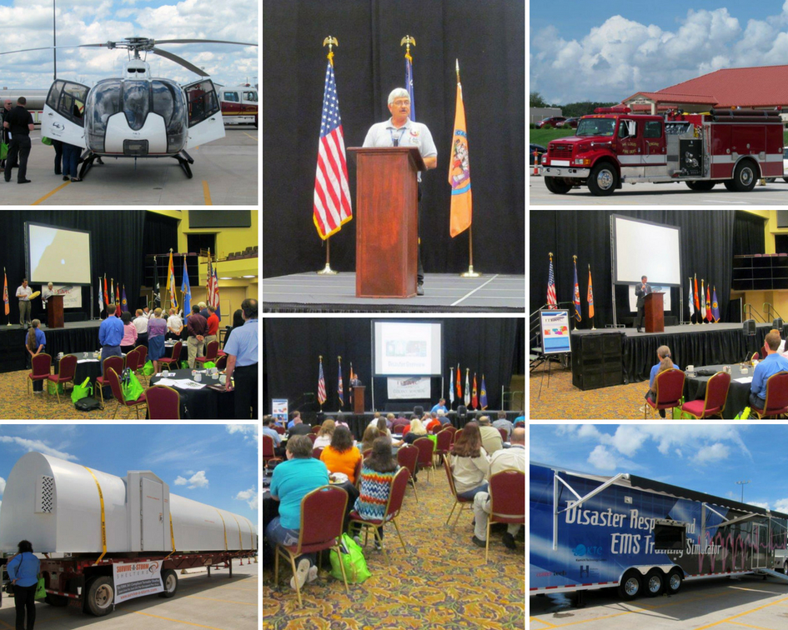

**ABOUT ITEMC**

**ITEMC was formed in December 2004 as learning and networking resource for Tribal Emergency Management professionals. Because of the checker-board layout of our tribal lands, the need for networking, enhancing and strengthening our working relationships with Federal, State, County and City governments soon became paramount. The first Summit was held in June 2008 with about 180 attendees and has grown each year. The Summits are designed to help those involved in Emergency Management to overcome misconceptions about jurisdictional boundaries, organization, tribal resources, and receiving federal assistance. It has evolved into an excellent opportunity for Tribal, Federal, State, and local officials to network with other agencies and organizations.**

**ITEMC BOARD MEMBERS**

Jeff Hansen – Choctaw Nation Polly Edwards – Caddo Nation

Sara Billings – Chickasaw Nation Sylvia Tulsa – Muscogee (Creek) Nation

Tim Zientek – Citizen Potawatomi Nation

**ITEMC WOULD LIKE TO SAY “THANK YOU!” TO ALL THE ATTENDEES, SPEAKERS, VENDORS AND SPONSORS FOR MAKING THIS ANOTHER SUCCESSFUL SUMMIT!**

**OKLAHOMA FEDERALLY RECOGNIZED TRIBES**

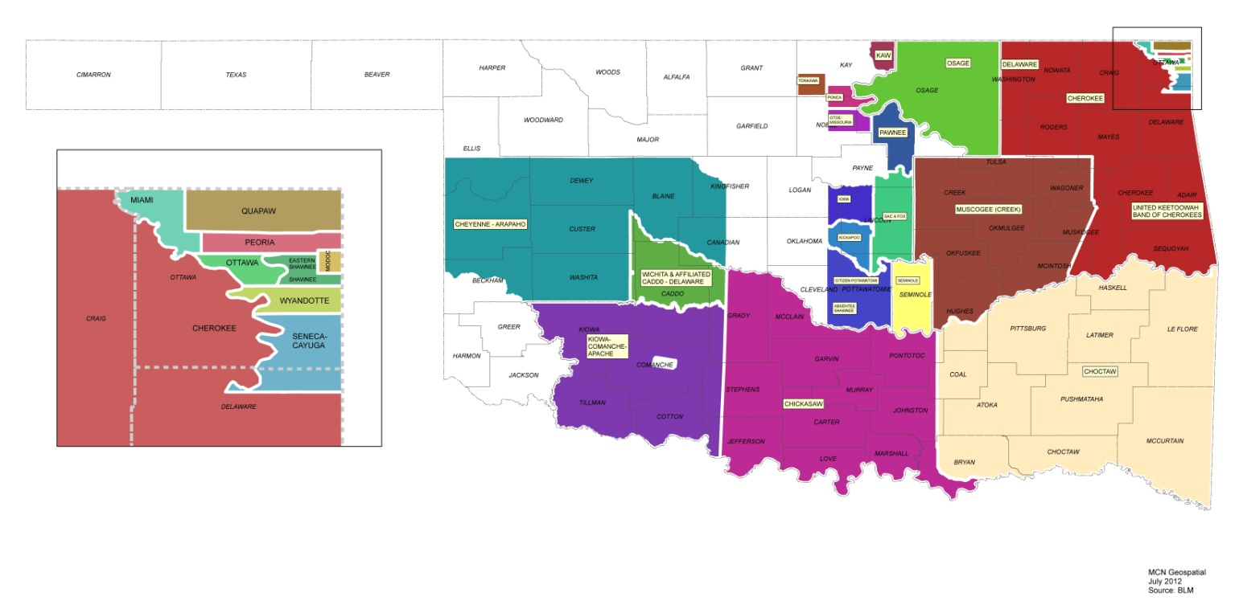

ABSENTEE SHAWNEE TRIBE FORT SILL APACHE TRIBE PEORIA TRIBE

ALABAMA QUASSARTE TRIBAL TOWN IOWA TRIBE PONCA TRIBE

APACHE TRIBE KAW NATION QUAPAW TRIBE

CADDO NATION KIALEGEE TRIBAL TOWN SAC & FOX NATION

CHEROKEE NATION KICKAPOO TRIBE SEMINOLE NATION

CHEYENNE-ARAPAHO TRIBES KIOWA TRIBE SENECA CAYUGA TRIBE

CHICKASAW NATION MIAMI TRIBE SHAWNEE TRIBE

CHOCTAW NATION MODOC TRIBE THLOPTHLOCCO TRIBAL TOWN

CITIZEN POTAWATOMI NATION MUSCOGEE CREEK NATION TONKAWA TRIBE

COMANCHE NATION OSAGE NATION UNITED KEETOOWAH (BAND OF

DELAWARE NATION OTTAWA TRIBE CHEROKEE INDIANS)

DELAWARE TRIBE OTOE-MISSOURIA TRIBE WICHITA & AFFILIATED TRIBES

EASTERN SHAWNEE TRIBE PAWNEE NATION WYANDOTTE NATION

## SUMMIT TEAM

|  |  |  |
| --- | --- | --- |
|  |  |  |
|  |  |  |
|  |  |  |
|  |  |  |
|  |  |  |

~~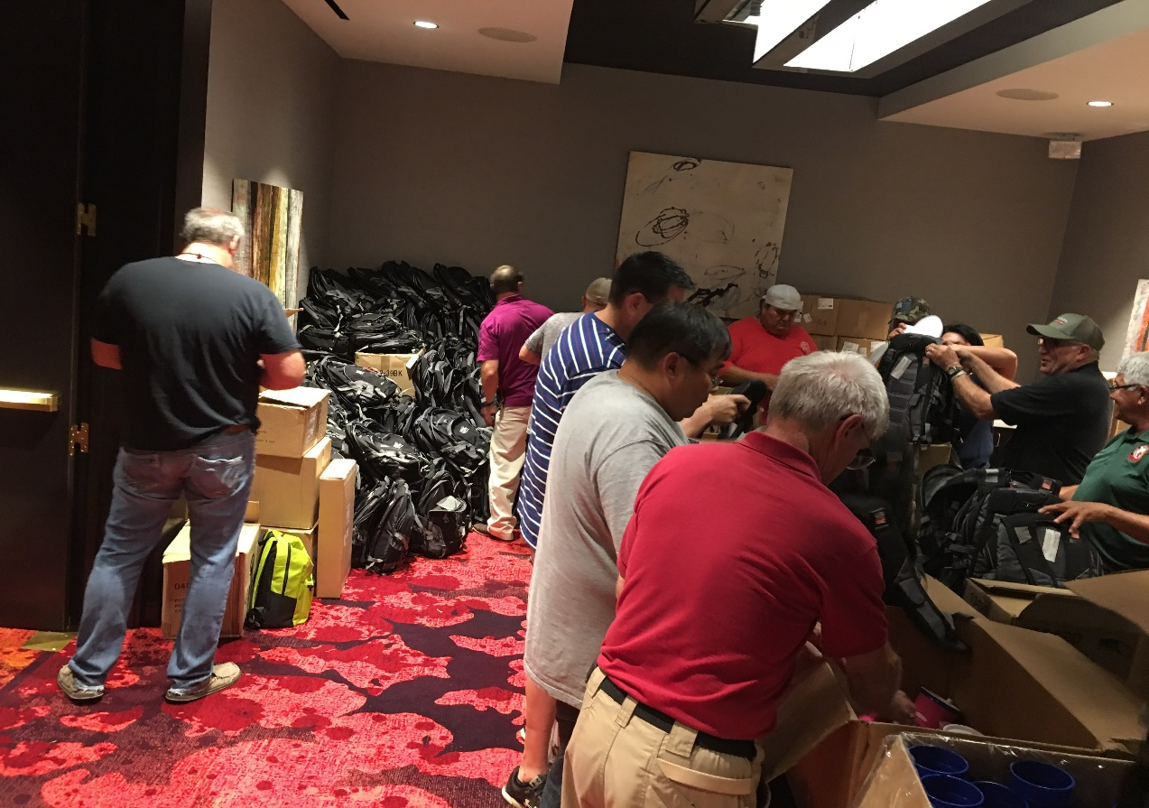~~

~~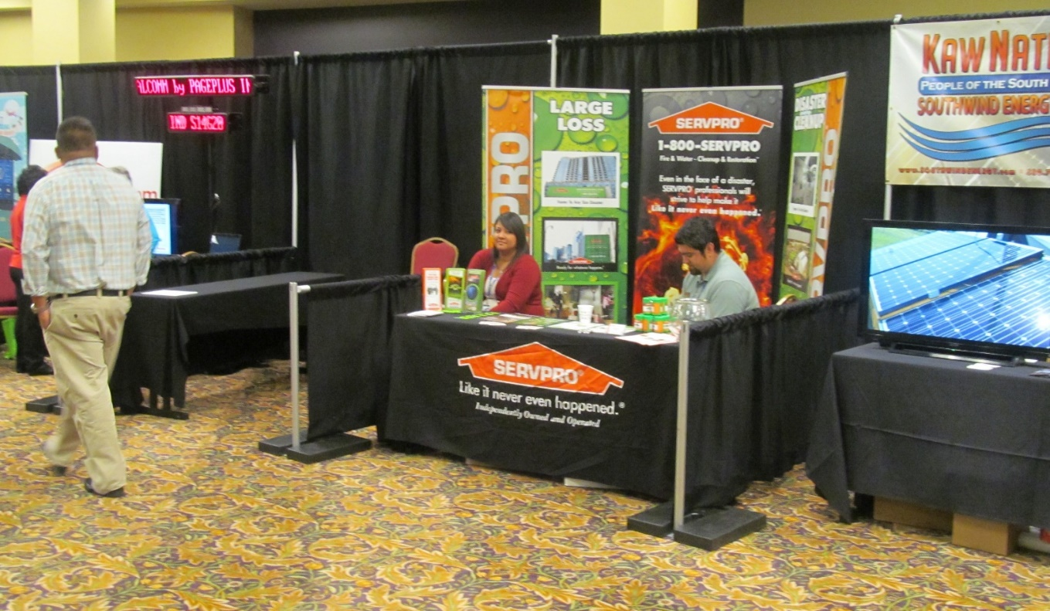~~

~~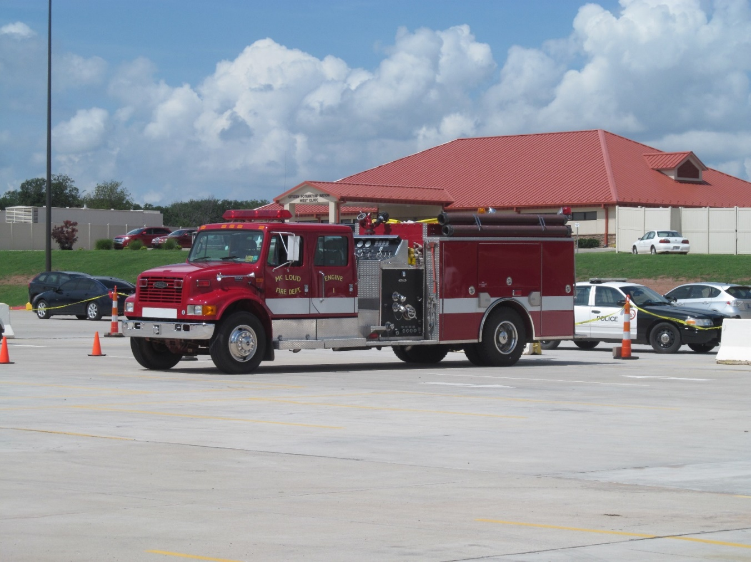~~

~~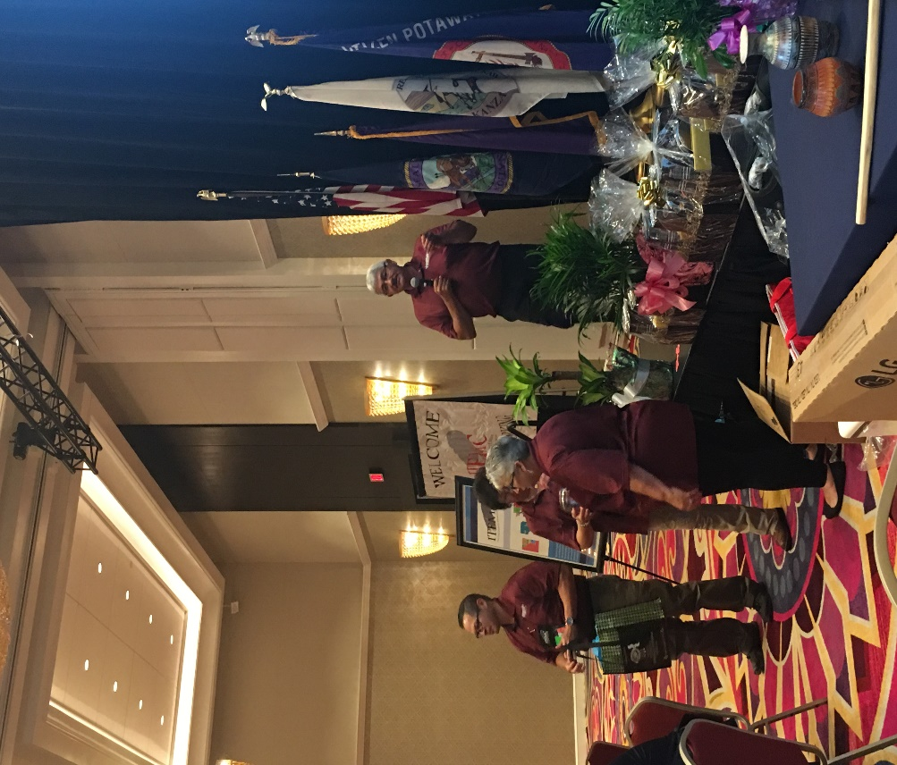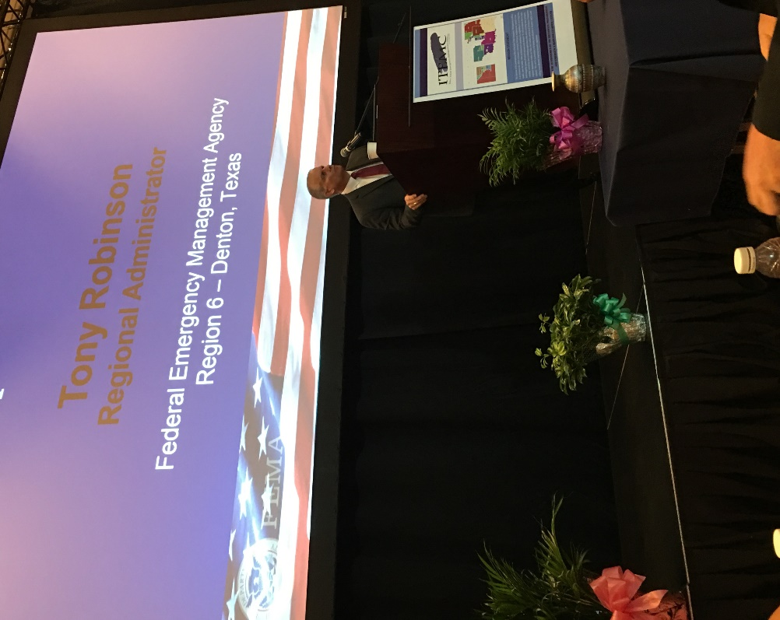~~

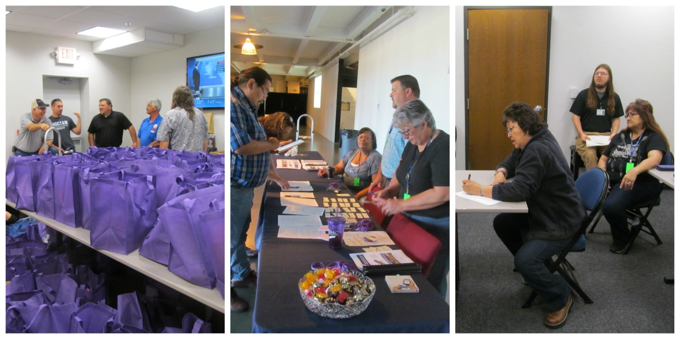

**ITEMC 2023**